SmartHirePro

Hrushikesh Joshi1, Yash Jani*2, Seungah Choi3,Sujay Sail4

*Seidenberg School Of Computer Science and Information Systems - Pace University*

1hj85754n@pace.edu

2yj16719n@pace.edu

3sc02316n@pace.edu

4ss36001n@pace.edu

***Abstract*— Abstract— SmartHirePro, a job recommendation system designed for recent graduates and young professionals, tackles the challenge of navigating the online job market. It analyzes resumes to extract key skills using YAKE!, a keyword extraction technique that prioritizes the most relevant skills. Leveraging a large language model, SmartHirePro then matches these skills with relevant job postings retrieved from an external job board API. The system employs a multi-stage approach that includes resume preprocessing, skill extraction, and job matching based on skill similarity. By recommending suitable jobs and offering insights into their skill set, SmartHirePro empowers job seekers to navigate the online job market more effectively and potentially chart their career path.**

***Keywords***— **Keywords, Extraction, Skills, Recommendations, Jobs**

1. Introduction

The way people look for work has changed significantly as a result of the internet's explosive expansion. Employers are starting to use job boards to find talent as more and more job seekers publish their resumes and professional details online. According to a Jobvite survey, a large proportion of job searchers who apply online are recent college grads or postgraduates, and a considerable proportion of recruiters use social media to find candidates. This pattern emphasises how important job searching online is becoming.

It can be a real pain to look for suitable work online if you're a recent graduate or young professional still building your resume. Their selection of filters is limited, and university career services often do not have sophisticated matching algorithms. Ideally, these job sites would also serve as career advisors, connecting users with in-demand expertise.

In order to assist job seekers in overcoming the aforementioned challenges, this study introduces SmartHirePro, a cutting-edge recommendation system. SmartHirePro provides clients with two primary recommendations, namely jobs and skills, by utilising collaborative filtering algorithms and text mining with an emphasis on students and young professionals. By recommending suitable employment, SmartHirePro helps people in their job hunt. Furthermore, the skill recommendations help users pinpoint areas where they might need to further develop in order to match the demands of today's job market. By using this integrated technique, users are better able to find suitable employment opportunities and get insightful knowledge that will enhance their skill sets and increase their marketability.

1. Literature Review

In the dynamic job market, job suggestion systems have grown in importance as resources for companies and job seekers alike. Through the identification of appropriate work prospects based on their qualifications and expertise, these systems help job seekers. This review of the literature examines current methods for skill extraction and job recommendation systems, emphasising how they apply to SmartHirePro, a new job recommendation system that focuses on resumes.

*A. Job Recommendation Systems*

A framework for recommending career paths, called CaPaR [1]: This study presents CaPaR, a system that uses collaborative filtering techniques and text mining to recommend skills and jobs to users. CaPaR is aimed at students and young professionals, much like SmartHirePro. But one important difference is that SmartHirePro's method might not include collaborative filtering.

Effective re-education utilising resumes for career recommendations is conceivable in work environments that are changing more and more [2]: This study investigates how career counselling might be given using resumes in a changing labour market. SmartHirePro focuses on connecting talent to employment; this may pave the way for future SmartHirePro capabilities enhancements. While Ashrafi et al.'s technique delivers significant insights for identifying skill shortages and recommending re-education opportunities, SmartHirePro matches talent to jobs.

*B. Skill Extraction Techniques*

Extracting skills from resumes is one of the most crucial phases in job recommendation systems. The papers that follow look at different strategies for completing this task:

Method for Combining Multiple Features Extraction of Keywords TextRank [3] is based on the following: This study presents an extraction strategy for keywords based on TextRank. For SmartHirePro to identify competencies from resumes, keyword extraction is necessary. While YAKE! is employed by SmartHirePro, this study provides a different approach (TextRank) for potential analysis and comparison.

YAKE! Multiple local features are used to extract keywords from a single document [4]: This paper presents YAKE!, a multi-feature keyword extraction technique. YAKE! is utilised by SmartHirePro to extract abilities from resumes. This document provides important insights into the internal workings of YAKE! and the reasoning behind the features that were selected.

*C. Areas for Further Exploration*

The following important areas require further research after a careful evaluation of the literature:

Adapting to Shifting Labour Markets In what ways do the existing job recommendation systems address the challenge of rapidly evolving labour markets and increasing skill requirements? [2] and other similar works could provide helpful information in this regard.

contrasting several approaches to skill extraction How precise and effective, in comparison to YAKE!, are alternative keyword extraction methods for skill extraction from resumes, such as TextRank [3] SmartHirePro's skill extraction process might be improved by looking at these parallels.

*D. Conclusion*

The research that has already been done on skill extraction methods and job recommendation systems has been reviewed in this literature review. The reviewed works provide insightful information that guides SmartHirePro's development. Future studies should look into different methods for extracting skills for possibly better performance, as well as how job suggestion algorithms might adjust to changing job markets.

1. Relevance

From manual resume checks to Applicant Tracking Systems (ATS) that automate some portions of candidate assessment, technology has drastically changed traditional recruitment processes. Since keyword matching plays a major role in these systems, applicants with unusual career trajectories or a variety of skill sets that don't precisely fit job descriptions may be overlooked.

Technology has substantially altered traditional recruiting methods, from manual resume reviews to Applicant Tracking Systems (ATS) that automate parts of the candidate screening process. These systems heavily rely on keyword matching, thus candidates with non-traditional career paths or a wide range of skill sets that don't perfectly match job descriptions could be passed over.

These limitations are addressed by recent developments in AI and machine learning, which offer more thorough assessments of resumes and job advertisements. For example, semantic analysis improves match accuracy by providing a richer knowledge of synonyms and context. Even with these encouraging developments, there is still potential for more innovation because the full adoption of such complex systems has not yet occurred.

Even with these developments, there is still a great need for easily usable, useful, and profitable job matching services that cater to a wider spectrum of companies and job seekers, especially in quickly evolving labor markets. The complexities of matching individuals' soft talents to job criteria that go beyond keyword matching pose a challenge for many systems.

*A. Building the Case for Usefulness*

By developing a more approachable and user-friendly platform that leverages AI to improve resume and job matching, the current study aims to close these gaps. Instead of just overloading the keywords, the project's core focus on talent and experience extraction along with the use of more sophisticated NLP approaches will help in comprehending the meanings and context of the keywords. Users will be able to determine whether their resumes are aimed at the incorrect

By increasing the precision and applicability of job matches, this initiative can greatly improve the effectiveness of the hiring process for both companies and job seekers. It raises the likelihood that competent job seekers will find relevant possibilities that they might not have found using more conventional search techniques. Employers can anticipate a more varied pool of applicants who are precisely matched to the job requirements and who actually use keywords in the right context—as opposed to simply copying and pasting them to improve matches.

*B. Advancing Understanding and Significance*

The current discussion about the use of AI in HR technology is aided by this initiative. Emphasizing a practical, step-by-step methodology, it offers insightful information about how gradual AI integration might have a noticeable effect in real-world scenarios.

The project's lessons will also be used to assess the scalability of AI-driven hiring solutions, providing a roadmap for how these technologies might develop to adapt to shifting market demands.

1. Methodology

Using a multi-stage recommendation system, SmartHirePro matches users with jobs based on their resumes. Below is a thorough explanation of every phase:

*A. Resume Preprocessing:*

At this point, the resume is guaranteed to be prepared for efficient skill extraction. It involves a number of smaller processes:

* Noise removal: Extraneous details such as headers, footers, contact information, and style components are removed. For this, methods such as pre-defined elimination patterns and regular expressions can be used.
* Formatting Correction: Formatting inconsistencies are resolved. This could entail fixing any layout problems, unifying spacing and font variances, and turning various bullet point styles into a common structure.

*2. Skill Extraction:*

Using the preprocessed CV, this important step determines the applicant's essential skills. YAKE!, a keyword extraction method that SmartHirePro uses, has the following benefits:

* Multi-Feature Analysis: YAKE! gives each keyword a relevance score based on a number of factors[4]. Document frequency (the number of times a keyword appears in the resume), document position (words in titles or strong fonts may be more important), and maybe part-of-speech analysis (concentrating on nouns and verbs indicative of talents) are some examples of these features.
* Tailored Extraction: YAKE! lets you customize the extraction process with user-defined parameters[4]. For example, stop-word lists can be used to remove common terms that don't indicate abilities, and minimum character length filters can be used to delete irrelevant single words.
* Top-Ranked Skills: The user's most prominent skills are represented by a predetermined number of top-ranked keywords that YAKE! chooses based on the relevance scores that have been assigned. This guarantees that for accurate job matching, the system concentrates on the most important abilities.

*C. Job Matching and Recommendation:*

Linking the user's talents to appropriate career prospects is the goal of this stage. There are various steps in the process:

* Job Data Acquisition: To gain access to a vast database of job ads, SmartHirePro uses an external job board API. The particular API selected will vary depending on variables such as access costs, update frequency, and data coverage.
* Parsing a job description: To maintain uniformity, job descriptions may go through some basic cleaning and parsing, much like resume preprocessing. This could entail eliminating extraneous formatting components or HTML tags.
* Similarity Matching: SmartHirePro uses a broad language model (e.g., spaCy's en_web_core_lg) to evaluate how well the user's abilities match the job requirements. This model does more than just match keywords. By representing words and phrases as numerical vectors that capture their semantic relationships within the text, it conducts vectorization. The model determines a similarity score by comparing the skill vectors that were taken from the resume with the vectors from the job description. The degree of alignment between the user's talents and those listed in the job description is reflected in this score.

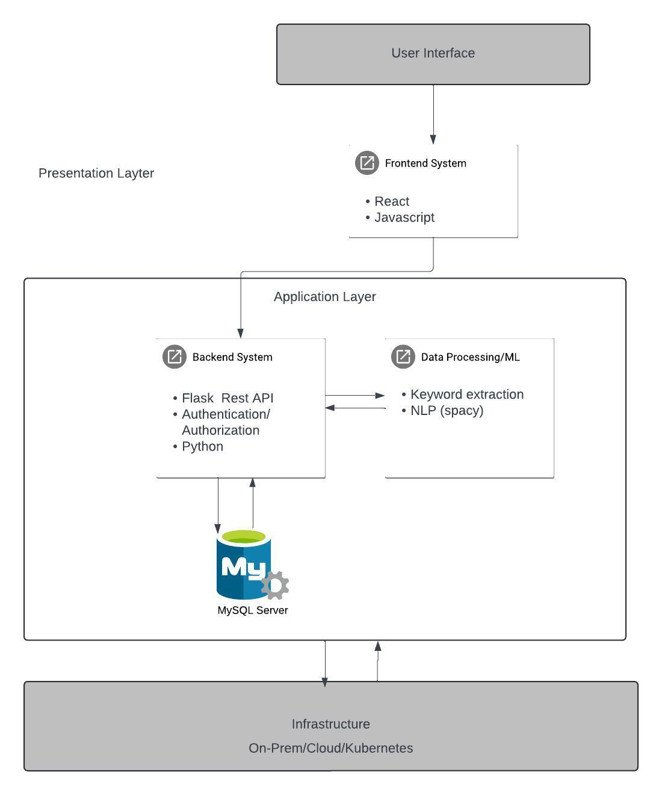

Fig. 1 An illustration of the system architecture

The precise methods employed for spelling and grammar correction, noise reduction, and formatting correction can be selected according to the features provided by the libraries or APIs that are available. Pre-built modules for these tasks are generally available from open-source libraries such as spaCy or NLTK.

YAKE! is a good fit for this work because of its adaptability and capacity to give priority to pertinent abilities[4]. To maximize skill extraction accuracy, many parameter settings can be experimented with.

The more comprehensive en_web_core_lg model is selected for job matching due to its vectorization capabilities, which allow a more nuanced understanding of the semantic relationships between skills mentioned in the resume and job descriptions. For named entity recognition tasks, a smaller spaCy model, such as en_web_core_sm, might be sufficient.

A deeper grasp of the many steps in SmartHirePro and the reasoning behind the selected technology is provided by this thorough methodology section. Large-scale social and economic ramifications also stem from this study. Raising the caliber of job matches can help ensure equitable pay, lower attrition, and increased job satisfaction. Thus, workforce development is supported, highlighting the project's noteworthy impact.

1. Conclusion

With its emphasis on advanced skill matching and resume analysis, SmartHirePro offers a fresh take on job suggestion systems. Through the expediting of their job search and the provision of pertinent recommendations based on their skill set, this approach empowers young professionals and recent grads. The potential benefits of SmartHirePro extend beyond better search performance. Through insights into a user's skill set, it can promote career development and increase self-awareness. In addition, SmartHirePro has the ability to democratize work chances for people with unconventional career trajectories by emphasizing talents rather than typical experience markers. This technology has advantages for companies and job seekers alike. Job seekers are empowered to successfully present their abilities and make connections with appropriate positions, while businesses can use the system to find qualified applicants based on skills and streamline the recruitment process. But responsible application is essential. It is important to take into account bias in skill extraction algorithms and an excessive dependence on automation. To protect user privacy, strong data security procedures are also necessary. SmartHirePro presents a bright future for employment recommendations that could be advantageous to all parties involved. Subsequent studies can improve its precision and investigate new aspects to augment its influence on the labor market.

Bibliography

[1] B. Patel, V. Kakuste, and M. Eirinaki, “CaPaR: A career path recommendation framework,” in *Proceedings - 3rd IEEE International Conference on Big Data Computing Service and Applications, BigDataService 2017*, Institute of Electrical and Electronics Engineers Inc., Jun. 2017, pp. 23–30. doi: 10.1109/BigDataService.2017.31.

[2] S. Ashrafi, B. Majidi, E. Akhtarkavan, and S. H. R. Hajiagha, “Efficient Resume-Based Re-Education for Career Recommendation in Rapidly Evolving Job Markets,” *IEEE Access*, vol. 11, pp. 124350–124367, 2023, doi: 10.1109/ACCESS.2023.3329576.

[3] W. Guo, Z. Wang, and F. Han, “Multifeature Fusion Keyword Extraction Algorithm Based on TextRank,” *IEEE Access*, vol. 10, pp. 71805–71813, 2022, doi: 10.1109/ACCESS.2022.3188861.

[4] R. Campos, V. Mangaravite, A. Pasquali, A. Jorge, C. Nunes, and A. Jatowt, “YAKE! Keyword extraction from single documents using multiple local features,” *Inf Sci (N Y)*, vol. 509, pp. 257–289, Jan. 2020, doi: 10.1016/j.ins.2019.09.013.